Inference :

Dependent variable : Survived

Independent variable : Sex , Age , Fare

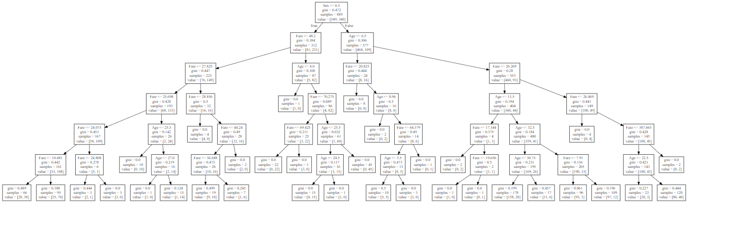

-> Out of 889 people , 312 is female and 577 is male .

-> 38 female whose fare is lesser than 10.481 have survived.

-> 70 female whose fare is between 10.481 and 24.808 have survived.

-> 14 female whose fare is more than 25.698 and age is more than 27 have survived.

-> 6 female whose fare is between 36.88 and 44.24 have survived.

-> 15 female whose age is below 24.5 and fare is between 69.425 have survived.

-> 5 male whose age is below 3.5 and fare is lesser than 66.379 have survived.

-> 1 male whose fare is between 17.344 and 19.656 and age is lesser than 13.5 have survived.

-> 20 male who were below 30.75 and whose fare is lesser than 26.269 have survived.

-> 12 male whose fare is between 7.91 and 26.269 and age below 32.5 have survived.

-> 3 male whose age is below 22.5 and fare lesser than 387.665 have survived.

-> 40 male whose age greater than 22.5 and fare is 387.665 have survived.